Computer Language Coding Concepts

Ancestry
A containment structure is also called an ancestry.

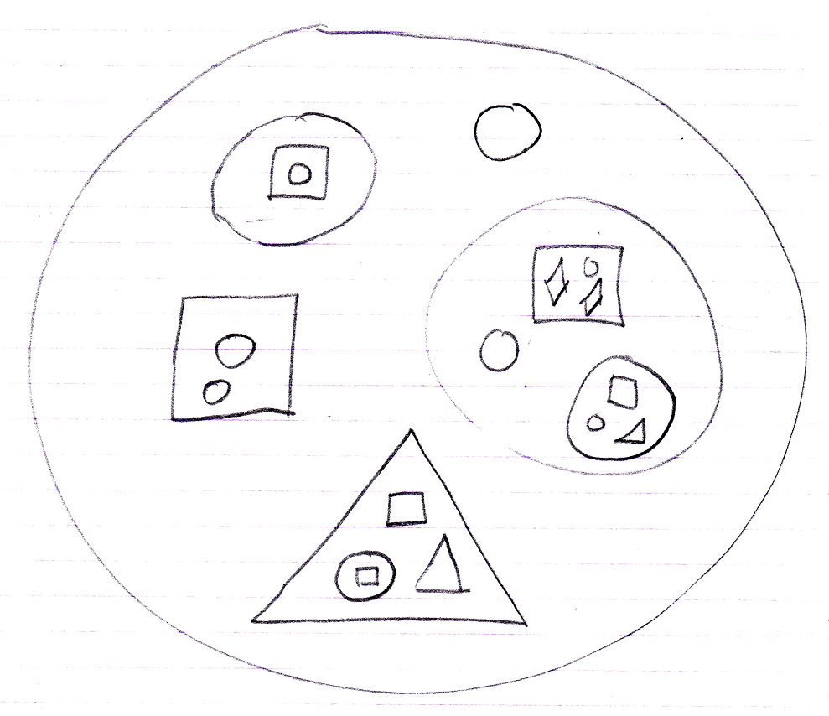

Terms for containment are analogous to the terms for ancestry.

I will mention all the terms around this analogy at a glance.

Deeper objects, the smaller, contained symbols, are called ancestors, because they are the elements that higher objects are composed of. Deeper objects are also called lower objects, analogous to lower species, that are less composite. Higher objects are called descendants, because they are derived of deeper objects and inherit from them. For that, containers are also called derived objects or derived types.

In more direct relationships the ancestry analogy changes. The analogy changes from related to genetics, to related to family ties. Grandma is considered higher in rank than a grandchild, but if it’s your great great great great great great grandma, then she’s considered genetically less evolved and lower. So the ranking changes in more direct kinship. Contained objects are lower, so ancestors. Directly contained objects are also lower: children.

This is normal for those who have programming in other object oriented languages, but if you are introduced to it for the first time it should be weird that children are ancestors. You can also speak of grandchildren and grandparents. The terms parent and child and related terms are always family rank related. In a way, a child is lower than a parent. In more distant relations, terms are related to genetic evolution: descendants are considered higher entities, while ancestors are lower.

A child object can also be called a base, or base object, because it forms the base of the parent.

A structure of containment is also called an ancestry. An ancestry with a lot of levels, or layers is also called a deep ancestry. A system with relatively little layers can be called a shallow ancestry. Deeper layers are also called bottom layers. Higher layers are also called top layers. A deep layer can also be called a foundation.

A parent can also just be called the container. A child, less often, the contained.

There are also the terms sub-object and super object. A sub-object is a child and a super object is a parent.

However, there are also the terms sub class and super class. A super class is a child and a sub class is the parent.

Each symbol in the ancestry can also be called a capsule, because it encapsulates other symbols.

The parent of a child can also be called the direct parent, to emphasize that it is about the capsule directly above the child. The same way, the parent has direct children. Grandchildren and deeper symbols can also be called indirect children, which makes the term indirect children a synonym for ancestors. The term direct can also be combined with the other terms, for instance directly contained, direct container.

Ancestry can also be called object structure.

An object’s sub-objects and command are also called the object’s members. The parameters of a command can also be called members of the command.

Other terms of family ties can be used just as well. Words such as cousins, siblings or uncle are allowed. Sibbling would be objects that directly reside in the same parent:

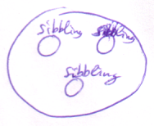

Cousins are objects whose parents are sibblings.

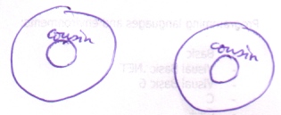

Terms
This introduces a lot of terms for ancestry. Here are most of them repeated in a list:

containment
containment structure
encapsulation
encapsulation structure
object structure
ancestry
level
layer
capsule
indirect
direct
super | sub
super object | sub-object
sub class | super class
container | the contained
parent | child
grandparent | grandchild
descendant | ancestor
shallow | deep
 | deeper
 | deeper object
 | deeper layer
shallow ancestry | deep ancestry
high | low
higher | lower
higher object | lower object
higher layer | lower layer
top | bottom
top layer | bottom layer
above | below
 | foundation
derived | base
derived object | base object
derived type | base type
derive
derivation
referrer | reference
 | member
inheritance
inherit
sibbling
cousin
uncle
direct parent | direct children
indirect parent | indirect children
direct container | directly contained
indirect container | indirectly contained
etcetera…

See also: System Objects

Author & Copyright: Jan-Joost van Zon Date: 2004 – August 31, 2009 Location: Breda / Oosterhout, The Netherlands Status: Finished

